Word 2007 Notes
The Ribbon – the new user interface presents commands in tabs, replacing the traditional menus.
The Office Button – One location for all the things you can do with a file such as open, save, print, etc…
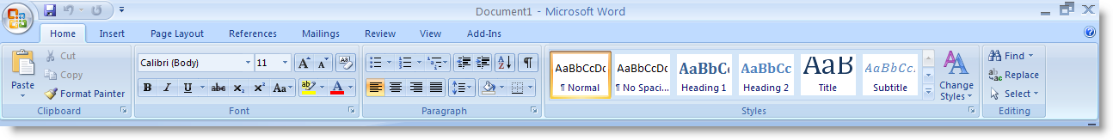
Quick Access Toolbar – A customizable toolbar that contains your most used commands.

Changing the Font Size
- Select the text you would like to change the size of
- On the Home tab, in the Font group, click the Font Size arrow
- Click the font size
OR
- Select the text you would like to change the size of
- Move the cursor slightly to display the Mini Toolbar, click the Font Size arrow
- Click the font size
OR
- Select the text you would like to change the size of
- To increase the font size, click the Grow Font button and keep clicking until the desired font size is displayed.
- To decrease the font size, click the Shrink Font button and keep clicking until the desired size is displayed.
Cut, Copy and paste text
- Select the text you would like to cut, copy or paste
- On the Home tab, in the Clipboard group, click the Cut or Copy button
- Position the insertion point where you want the item to appear
- On the Home tab, in the Clipboard group, click the Paste button
Formatting Tasks
Basic Tasks
Printing a file
- Click the Office button
- Click Print
- Choose a printer, number of copies, and other printing options before printing
Saving a file
- Click the Office button
- Click Save As
- Click the Save In down arrow
- Select the location where you would like to save the file
- Type the file name in the File Name box
- Click Save
Opening a file
- Click the Office button
- Click Open
- Click the Look In down arrow
- Choose the folder or drive where the file is stored.
- Choose the correct file.
- Click Open.
Exiting Microsoft Office 2007 Applications
- Click the Office button
- Select Exit.
Starting Microsoft Office 2007 Applications
- Click the Start button
- Point to All Programs, Microsoft Office, and then click the Microsoft Office 2007 application you wish to launch.

