Motivational Poster Planner
Portrait
Landscape
Circle one - Poster to go:

Picture that you want to use: ___________________________________________

Title: 1 (or 2 short) word(s) to go in large print right under the picture

Motivational text: 2-3 lines of text that explain or define the word above:

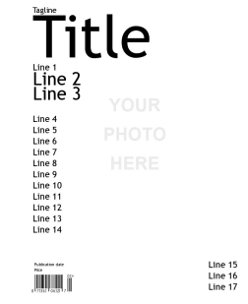
Magazine Cover Planner
Make sure to look at the template:

Make layout BLANK

Picture that you want to use: __________________________________________
Magazine Title (topic): ________________________________________________
Tagline: ____________________________________________________________
Line 1: _____________________________________________________________
Line 2: _____________________________________________________________
Line 3: _____________________________________________________________
Publication date:_____________________________________________________
Price: ______________________________________________________________
Line 15: ____________________________________________________________
Line 16: ____________________________________________________________
Line 17: ____________________________________________________________

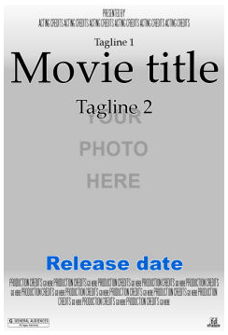
Movie Poster Planner
Make sure to look at the template:
Picture that you want to use: ________________________________________________
Movie Title (topic): ________________________________________________
Tagline 1: ________________________________________________
Tagline 2:
_______________________________________________
Acting Credits (at the top): ___________________________________________________________________
Production credits (at bottom): ___________________________________________________________________
___________________________________________________________________

Release date: ____________________________________

Trading Card Planner

Picture that you want to use: ___________________________________________
Circle color for your trading card:
- Earth (Brown)
- Sky (Red)
- Fire (Orange)
- Water (Blue)
- Onyx (Black)
- Quartz (Grey)

Title: 1 (or 2 short) word(s)

Sub - title: A short Phrase

Description: A few lines of text that explain or define the title:

___________________________________________________________________

