Flip Ultra Video Basics
Getting Started:
Turn the Power on by sliding the switch located on the right side of the device down.
The time at the bottom left displays how much recording time is available.
Push the power switch down again to turn off the Flip Video.
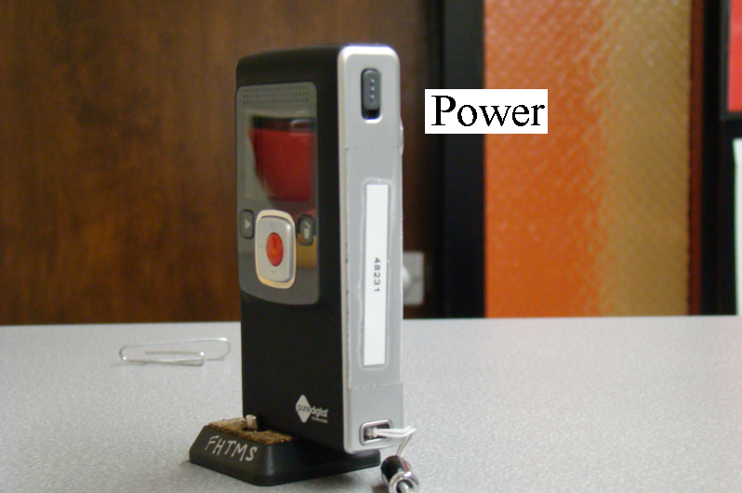
Recording:
Press the RED button to begin recording.
Press the RED button again to finish recording.
Press the ( + ) and ( - ) buttons above and below the red button while recording to zoom in and out.
Playing Back Your Videos:
To select a video you have just recorded, press on either arrow [<] or [>] to the right or left of the red button to locate your video.
Press Play │(top left) button once you have selected the desired video.
Press the Play │ button again to stop the video.
The ( + ) and ( - ) buttons above and below the red button control volume (four increments).
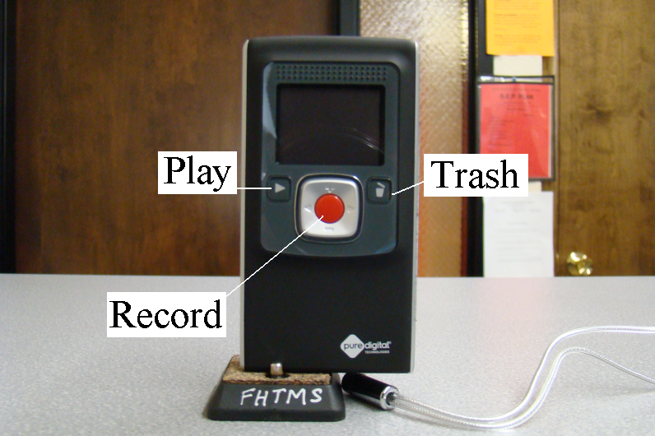
Deleting Videos:
One Video
Choose the video you want to delete with the arrow buttons.
Press the Trash button (top right) until the camera asks “Delete video?”
Press the Trash button again to delete the selected video
A screen will appear confirming deletion.
All Videos
Press and hold the Trash button (top right) down until the camera asks “Delete all videos?”
Press the Trash button again to delete all the videos.
A screen will appear confirming deletion.
To cancel the deletion of videos when the “Delete video?” or “Delete all videos?” message is displayed, wait several seconds without pressing any buttons.

Transferring Videos to the Computer:
Turn off the Flip Video and then turn on the computer (if it’s not already on).
Plug in the USB cable into the computer (the smaller end is the one that goes in the computer)
Flip the USB connector on the Flip Video out by sliding the latch on the side down.
Connect the open end of the cable to the USB connector on the Flip Mino. (Hold the casing around the USB connector on the Flip Video for support)
A window will pop up on the computer screen after several seconds.
Scroll down and select the option: Open folder to view files using Windows Explorer.
Click [OK]
A new window will appear on the computer screen.
Open the DCIM folder.
Open the 100VIDEO folder.
You can now view all your recorded videos.
Select/highlight the videos you wish to transfer.
Right click and select copy (or <Ctrl> <C>).
Open the folder or location you want to transfer the videos to.
Right click and select paste (or <Ctrl> <V>) in the desired folder.

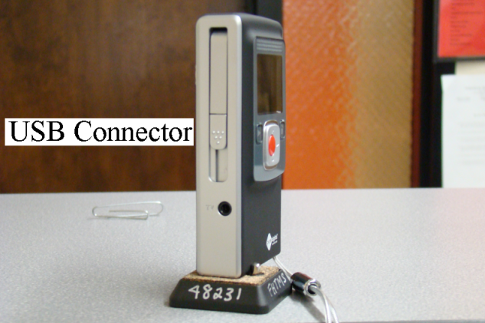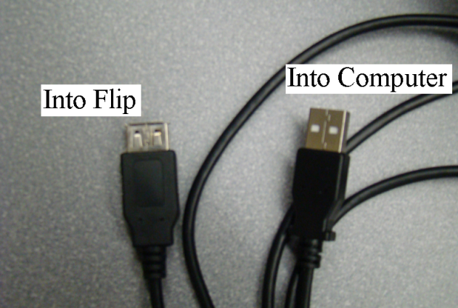
Disconnecting the Flip Video from the Computer:
When you have finished transferring all your videos, close all the open windows.
Click the Safely Remove Hardware button (the icon with the green arrow pointing left——at the right end of the task bar)
If the button is not visible, press the double arrow button () to display it.
This should display a Safely remove USB Mass Storage Device message.
Click the Safely remove USB Mass Storage Device message.
You should see a Safe To Remove Hardware message.
Click on the message and the Safely Remove Hardware button () should disappear.
Note: If you have a second USB device plugged into the computer, the Safely Remove Hardware button will not disappear until you disconnect that device, too.
You may now carefully unplug the USB cable from the computer.
Carefully unplug the Flip from the other end of the cable and put the cable away.
Put the USB connector on the Flip back into the slot.

